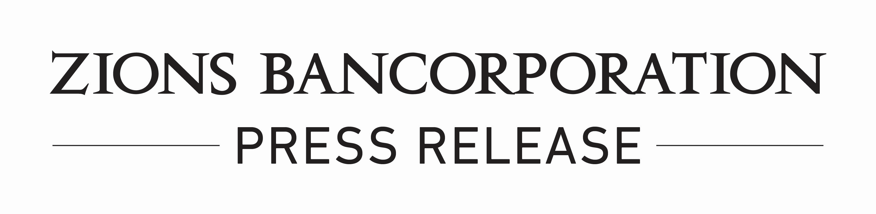

FOR: ZIONS BANCORPORATION Contact: Andrea Christoffersen
One South Main Street Director of Investor Relations
Salt Lake City, Utah Tel: (801) 844-7190
Harris H. Simmons
Chairman/Chief Executive Officer

ZIONS BANCORPORATION TO PRESENT AT THE
RBC CAPITAL MARKETS 2026 GLOBAL FINANCIAL INSTITUTIONS CONFERENCE

SALT LAKE CITY, February 24, 2026 – Scott McLean, President and COO of Zions Bancorporation, N.A. (NASDAQ: ZION), will make a presentation at the RBC Capital Markets Global Financial Institutions Conference on Tuesday, March 10th at 11:20 am Eastern. An audio webcast of the session may be accessed on the Zions Bancorporation website, zionsbancorporation.com. A replay of the presentation will also be made available following the event for one year.

Zions Bancorporation, N.A. is one of the nation's premier financial services companies with approximately $89 billion of total assets at December 31, 2025, and annual net revenue of $3.4 billion in 2025. Zions operates under local management teams and distinct brands in 11 western states: Arizona, California, Colorado, Idaho, Nevada, New Mexico, Oregon, Texas, Utah, Washington, and Wyoming. The Bank is a consistent recipient of national and state-wide customer survey awards in small- and middle-market banking, as well as a leader in public finance advisory services and Small Business Administration lending. In addition, Zions is included in the S&P MidCap 400 and NASDAQ Financial 100 indices. Investor information and links to local banking brands can be accessed at www.zionsbancorporation.com.
# # # # # # # # # # # # #

